Government Engineering College, Thrissur

CS333 – Application Software Development Lab
Documentation

Part I – Concept Presentation and ER Diagram

Basic Project Portfolio Management (PPM) Tool
for Small IT Companies

Date: 26 August 2020

Submitted By
Kowsik Nandagopan D
Roll No 31
TCR18CS031
GECT CSE S5

Contents
Project Portfolio Management Tool for Small IT Companies 3
Introduction 3
Entity-Relationship Diagram 3
Entity Types 4
Relationship Diagram 5
Conclusion 5
Reference 5

Project Portfolio Management Tool for Small IT Companies

Introduction
Project Portfolio Management is the centralized management of the processes, methods, and technologies used by project managers and project management offices to analyze and collectively manage current or proposed projects based on numerous key characteristics. Here in this mini-project much simplified version of the product is produced. Part 1 of this assignment will be an introduction to the Entity-Relationship(ER) Diagram.
The goal is to create an application with MySQL as the back end database server and apply different views to the data to convert into more useful information based on the user’s designation and status. As lab exercise we will be focusing on the different database functions and features. That includes establishing relationship between databases, creating constraints, Rollback, commit, save point, views, stored procedures and functions and many data analytic function that includes aggregation, groupings, etc...
As 18th lab exercise, we will be trying to implement the above features into a web based application.

Entity-Relationship Diagram
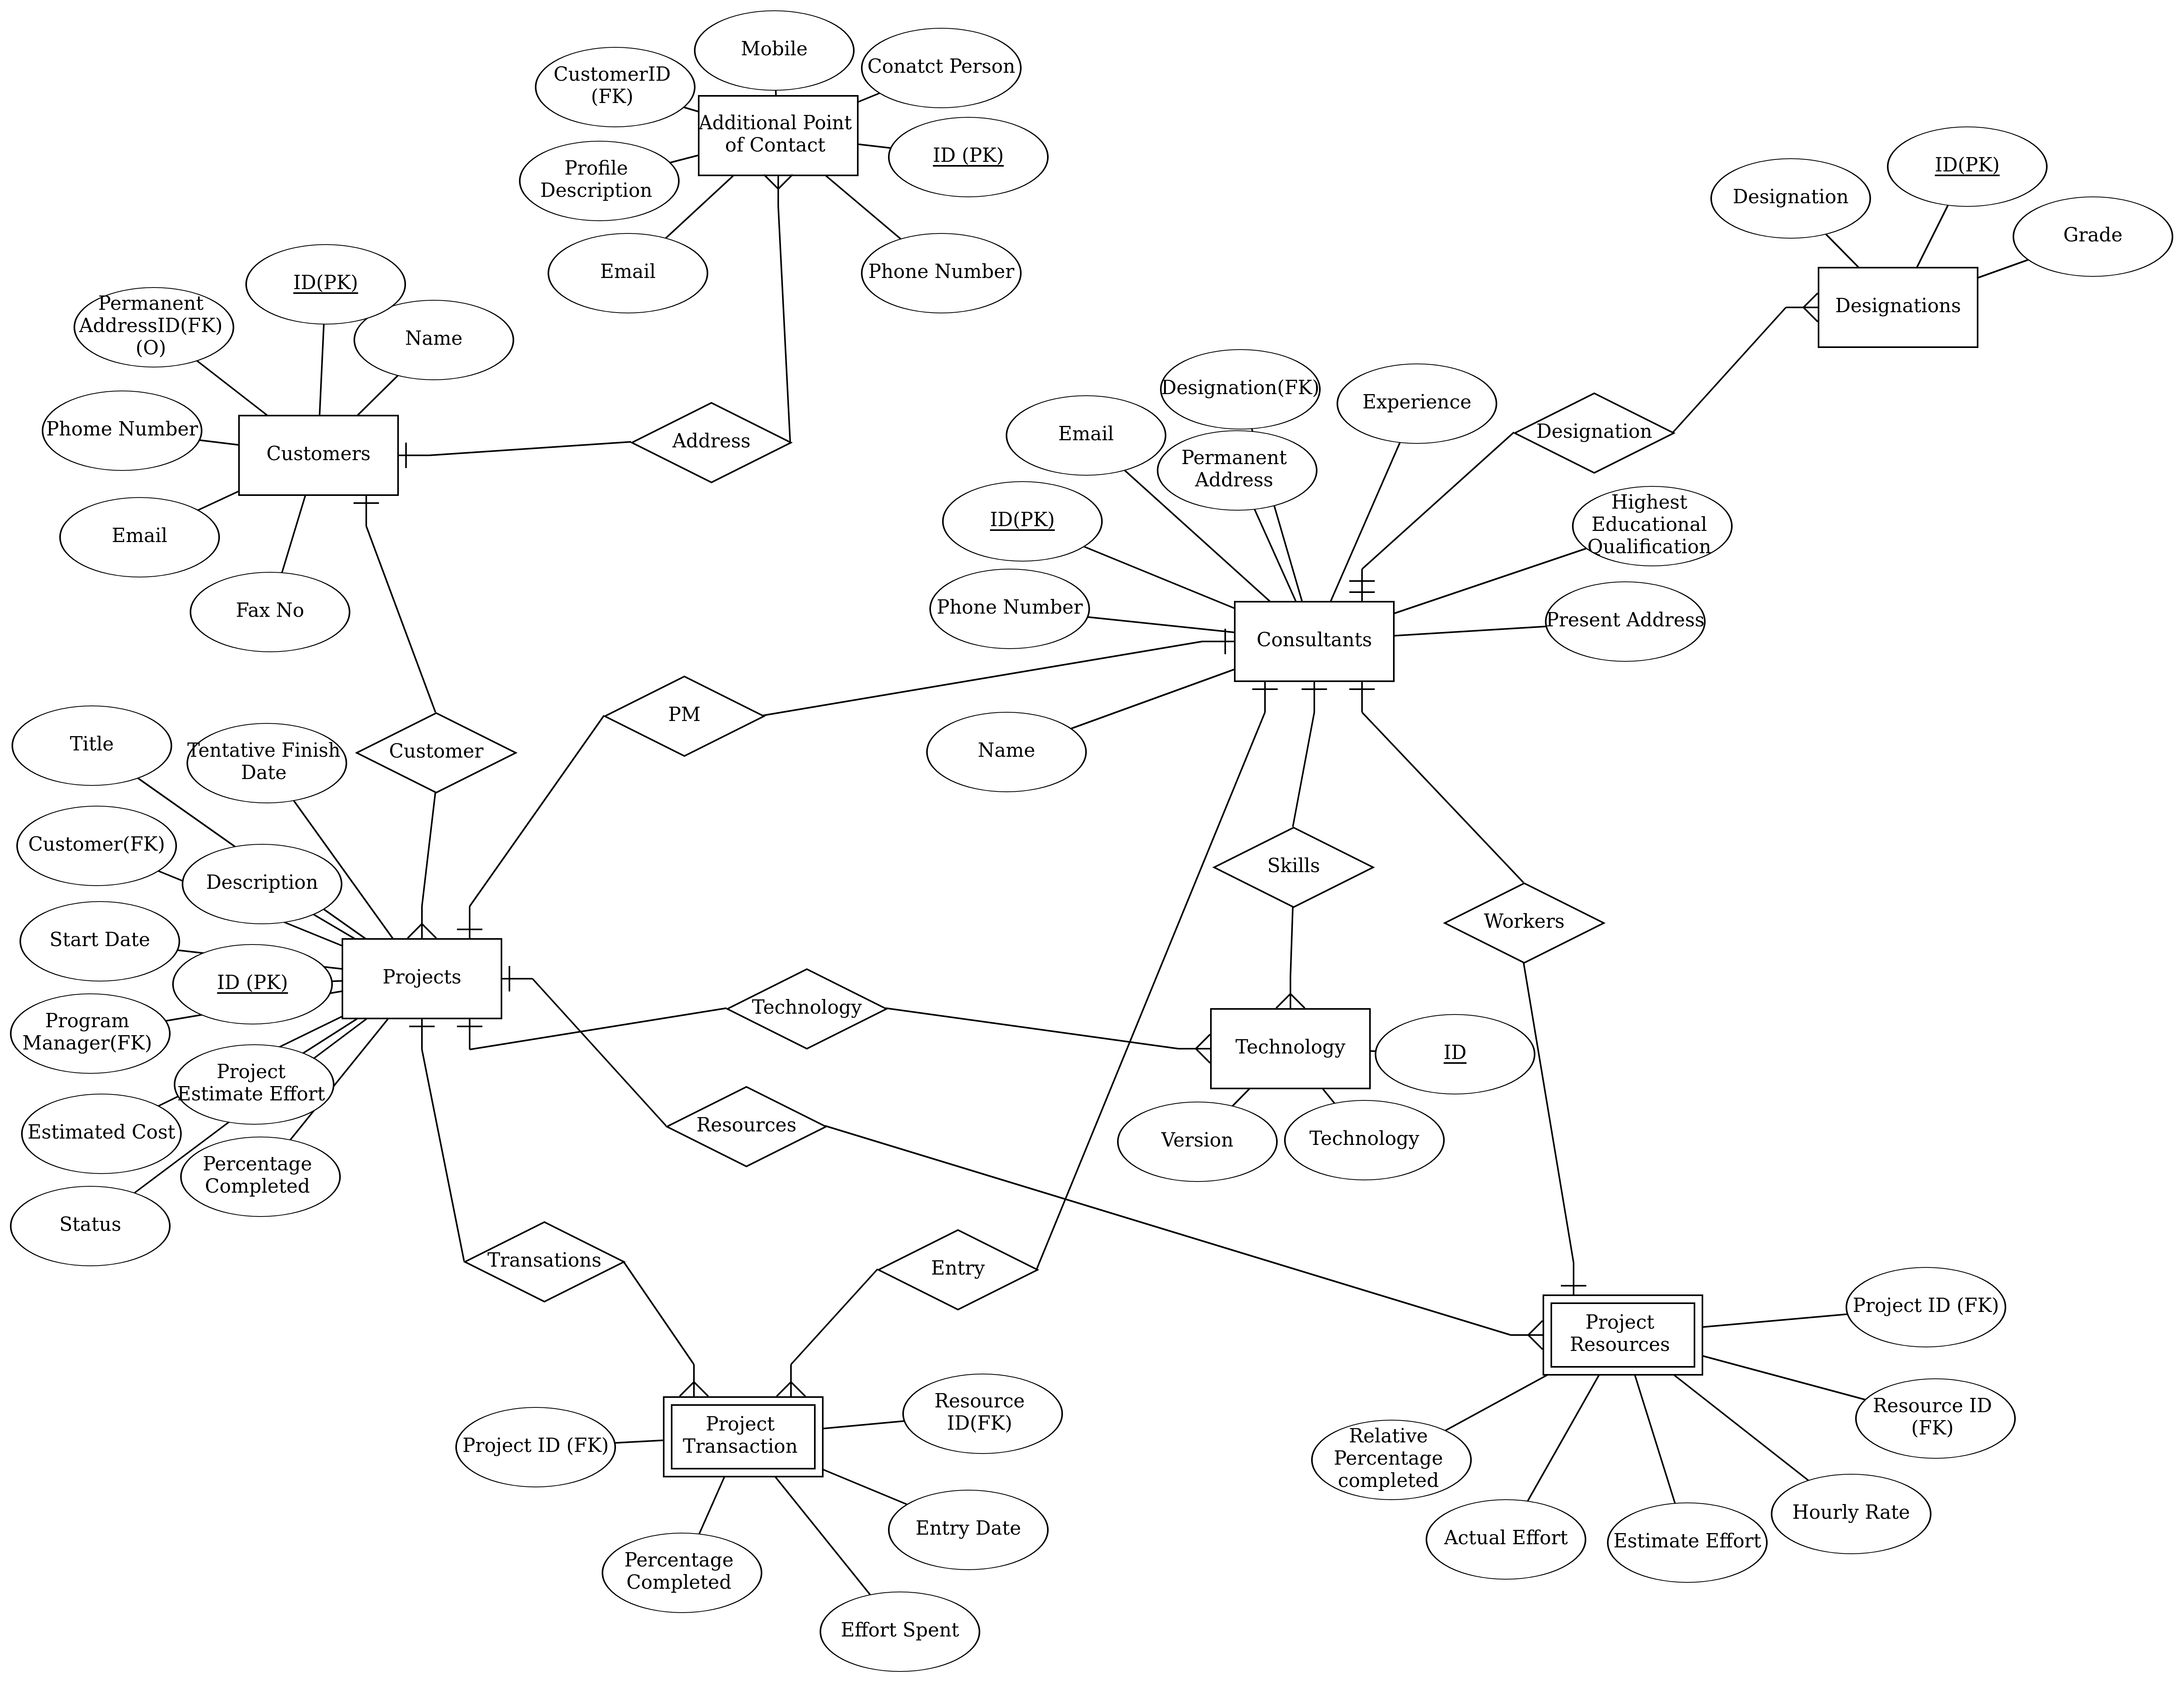
Small view of the entity relationship diagram is shown below. We should note that this ER diagram is prone to change over time. As we develop the application some more features will be introduced. Some of the tables are not shown here related to the user authentication and session management.
Complete, clear ER Diagram is uploaded Here or Last Page of this document

Entity Types
- Consultants: In Project Management we call the employees and staffs associated with the project as consultants. They will be having different attributes some of them are Name, Designation, Experience, different contact information and so on.
- Designation: The designation and rank/grade associated with the consultants are stored as separate entity for better management.
- Technologies: Skill sets of consultants are stored as different entity type. This is to link the technologies to the projects.
- Customers: Customers are the other companies those have given the request for the project. Since they are having different branches and different contact information these are stored in different entity type. However the primary contact information is stored as foreign key.
- Additional Point of Contact: Contact information of customers. The primary point of contact is stored in the customer table as a foreign key in the Customer entity type.
- Projects: This where all the entity types are linked. The attributes related to project are Project ID, Customer, Project Manager, Estimated cost, Tentative Finish Date, Status, Percentage completed, Project Estimated Effort. We link the consultants as resource for the project as different entity type.
- Project Resources: We call the human resource as project resource, people who are working for a project is an week entity and is linked with the project table with foreign key. Attributes are Estimated Effort, Relative percentage completed (How much percentage a consultant as completed in his total estimated contribution). Hourly rate (Cost per hour)
- Project Transaction: It is a log entered by each consultant associated with this project. They enter a value in how much hours they have spent on the project. The last entry value should be more than the previous. The last value entered by all consultants are aggregated to compute total percentage completed for the work.

Relationship Diagram

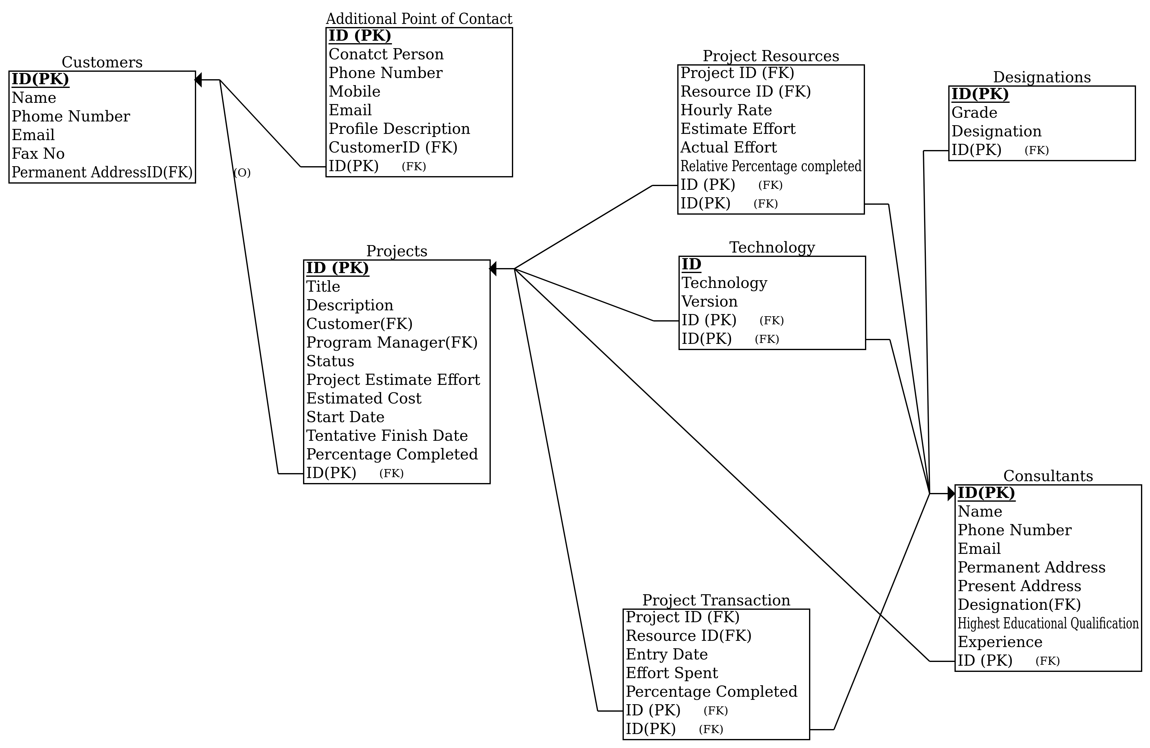
Complete, clear Relationship Diagram is in last page of this document

Conclusion
In this part we have seen ER Diagram for the Project Management Portfolio (PPM) for small IT companies. This ER Diagram are prone to change as we progress in development of the final project. Some of the most common entity types are avoided from the diagram, they include User authentication and session management. We will be including this in the final project. In actual project management environment we associate this PPM tool to other Project Management tool like Gantt or Agile. We will calculate much more data from those tools and make more informative. But for the simplicity of this mini-project and lab exercise we avoid such complexities. In Part II we will be doing much more exploration in the database and implement normalized ER diagram in the MySQL database.

Reference
- Project Management Portfolio : https://en.wikipedia.org/wiki/Project_portfolio_management
- ER Diagram Drawing Tool: https://erdplus.com

